**Assignment 4: Design Class Diagram**

Yilong Yu – Ben Powers – [Jaehyun](javascript://) Park

8170995 – 7986250 – 8105702

Systems Analysis and Design / INFO2320

[David Turton](https://conestoga.desire2learn.com/d2l/le/content/229806/viewContent/4630975/View) / [Sachin](javascript://) Parikh

November 19th, 2018

Team Name: Scoopy-doo

Teacher Name: [Sachin](javascript://) Parikh

Due: Nov 19, 2018 6:00 PM

**1. Domain Class Diagram (Associations & Multiplicity)**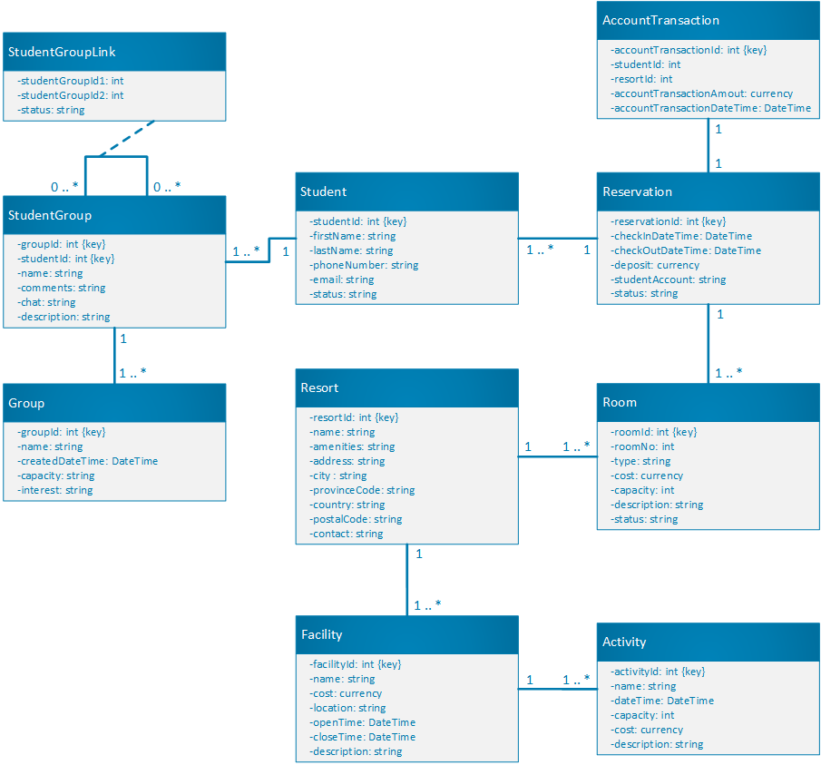

**2-1. Design Class Diagram (Use Case: Book Reservation)**

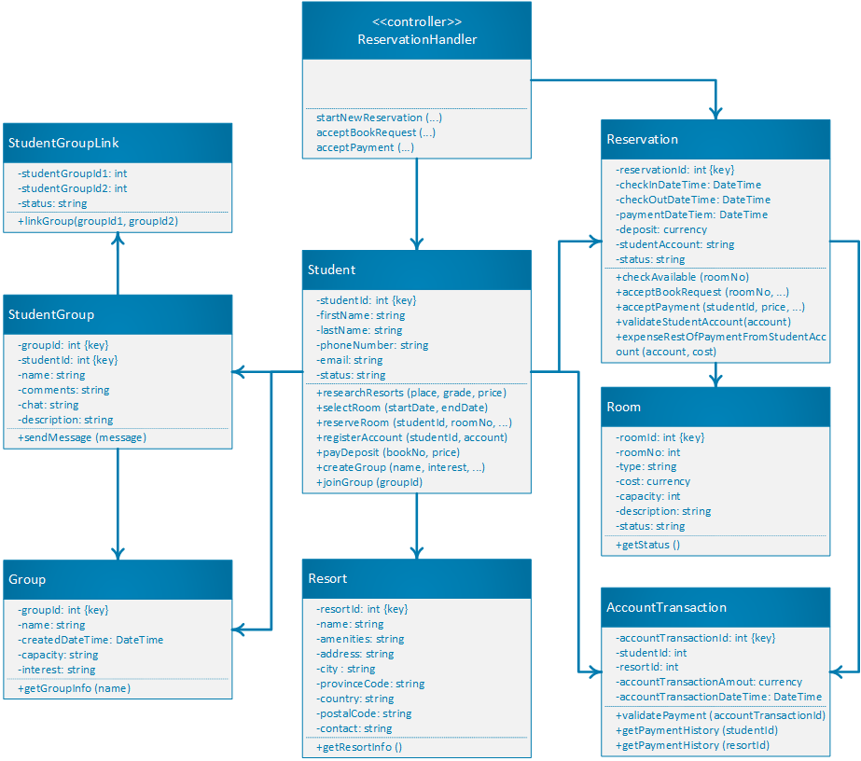

**2-2. Design Class Diagram (Use Case: Add New Resort)**

